18th November 2025
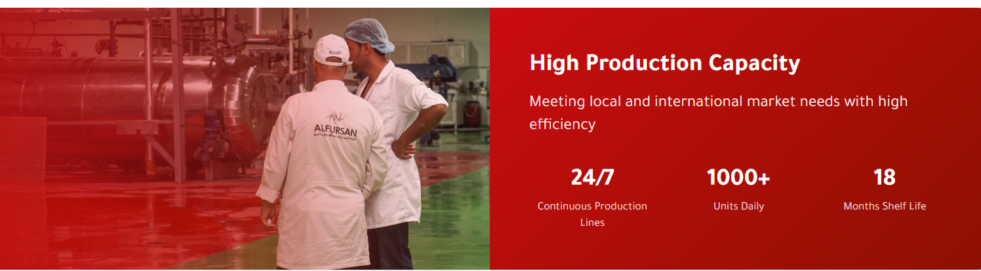

CHANGE SHELF LIFE TO
24MONTHS

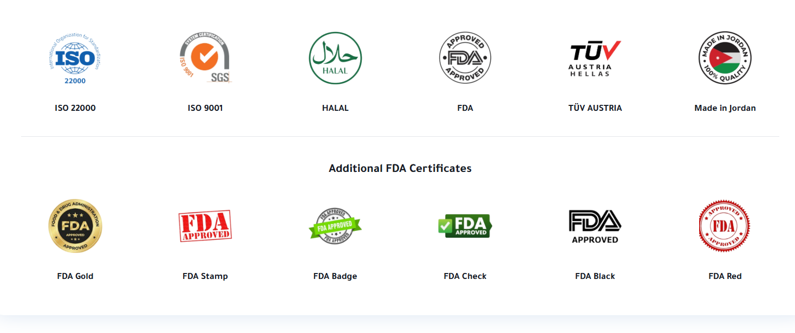
USE FDA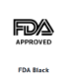 LOGO IN SECOND LINE INSTEAD OF LOGO ON FIRST LINE

CANCEL SECOND LINE

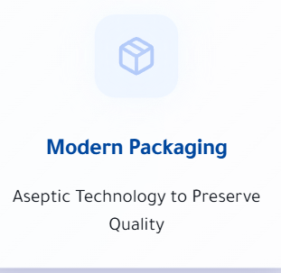

CHANGE ASEPTIC TO COMBI BLOCKS

VIDEO
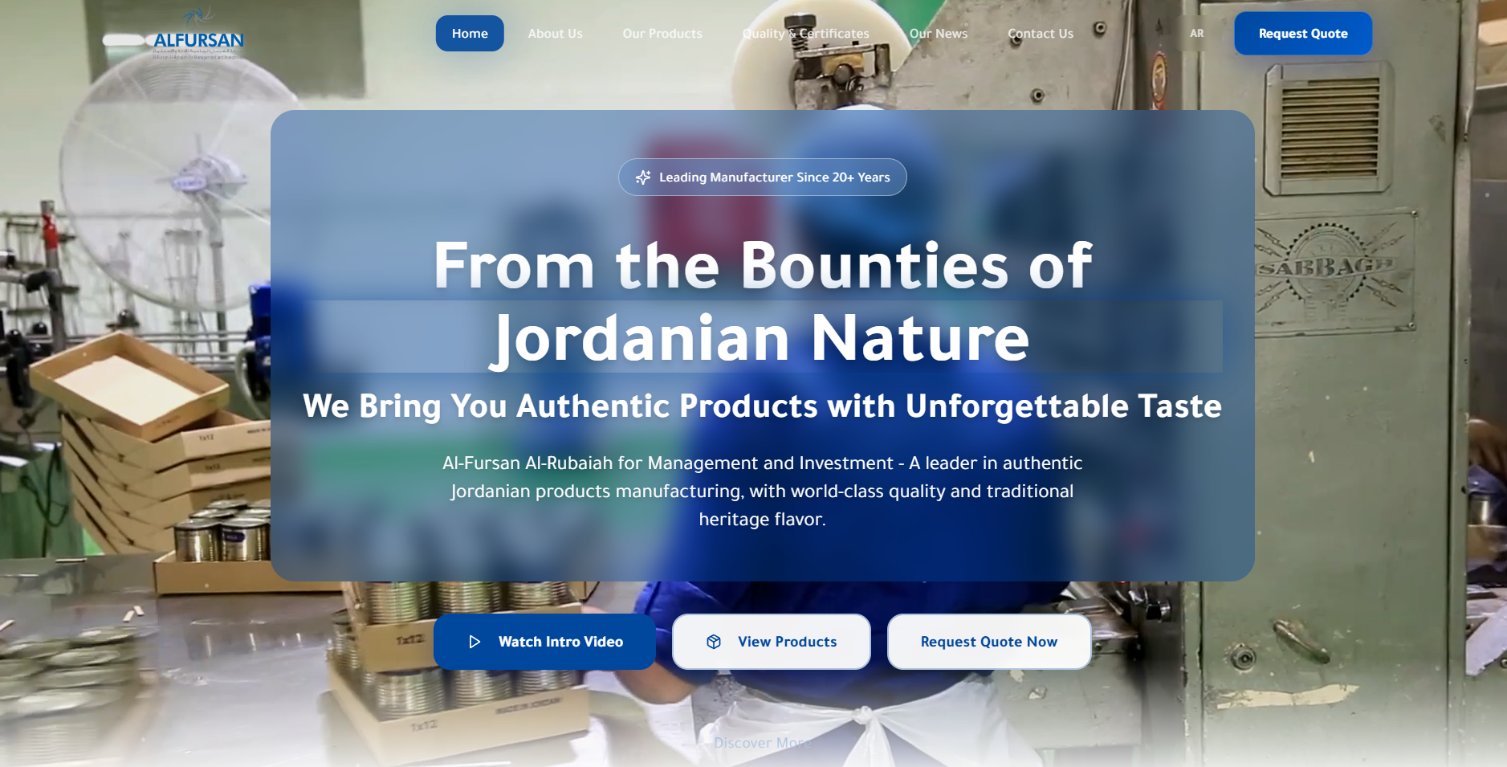
REMOVE CANS





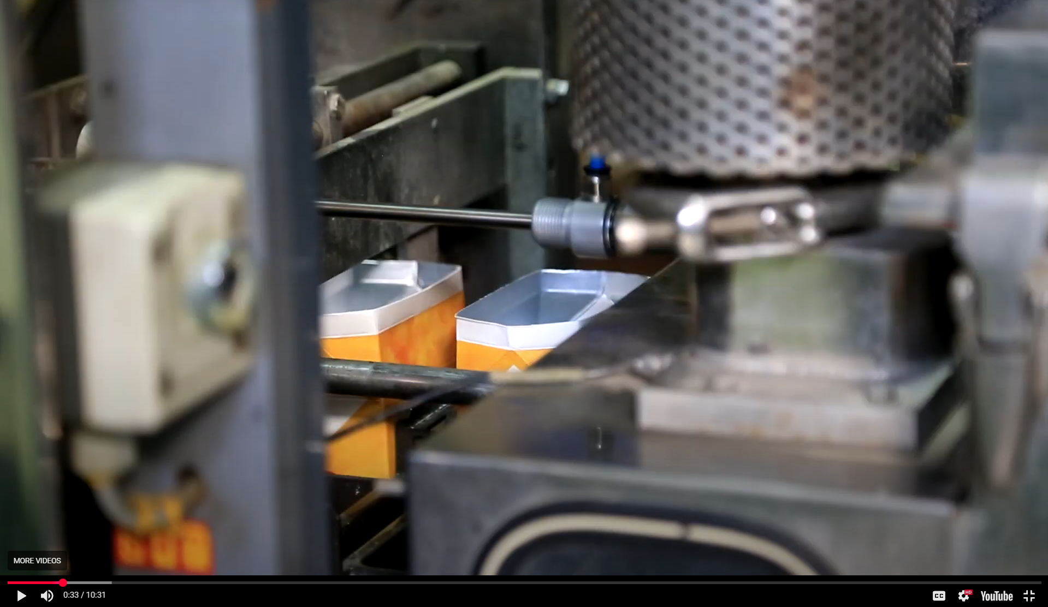

START FROM SEC 0:33 STOP AT SECOND 0:51

START FROM 1:02 STOP AT 1:13

START FROM SEC 1:41 ONLY
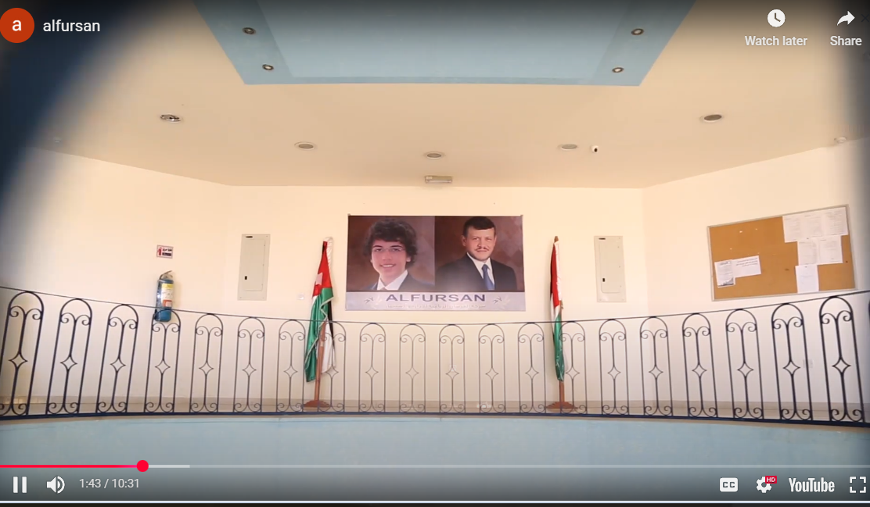 pic GIF
START AGAIN FROM 7:45 STOP AT 9:18

ADD OUTRO ALFURSAN LOGO

KEEP MENY BAR WHITE STATIC BACKGROUND

aBOUT US PAGE

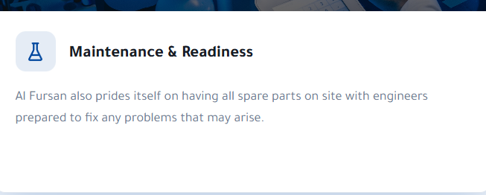

REPLACE PARAGRPAPH WITH LAB SECTION FROM PROFILE

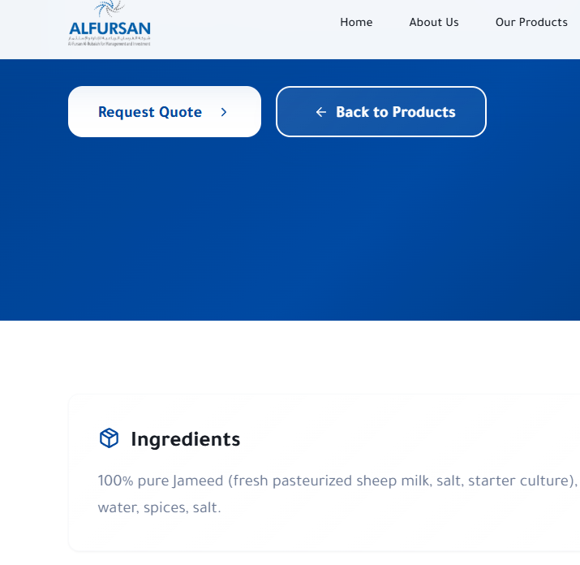
OUR PRODUCTS - CHANGE INGREDIENTS TO

100% pure Jameed stones, salt, starter culture, water, spices)

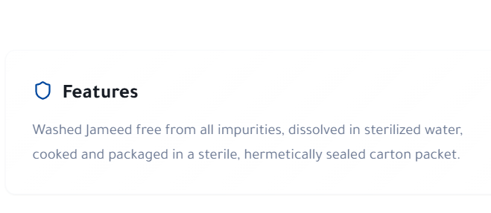 Jameed dissolved in sterilized water, cooked and packaged in combi block packaging.

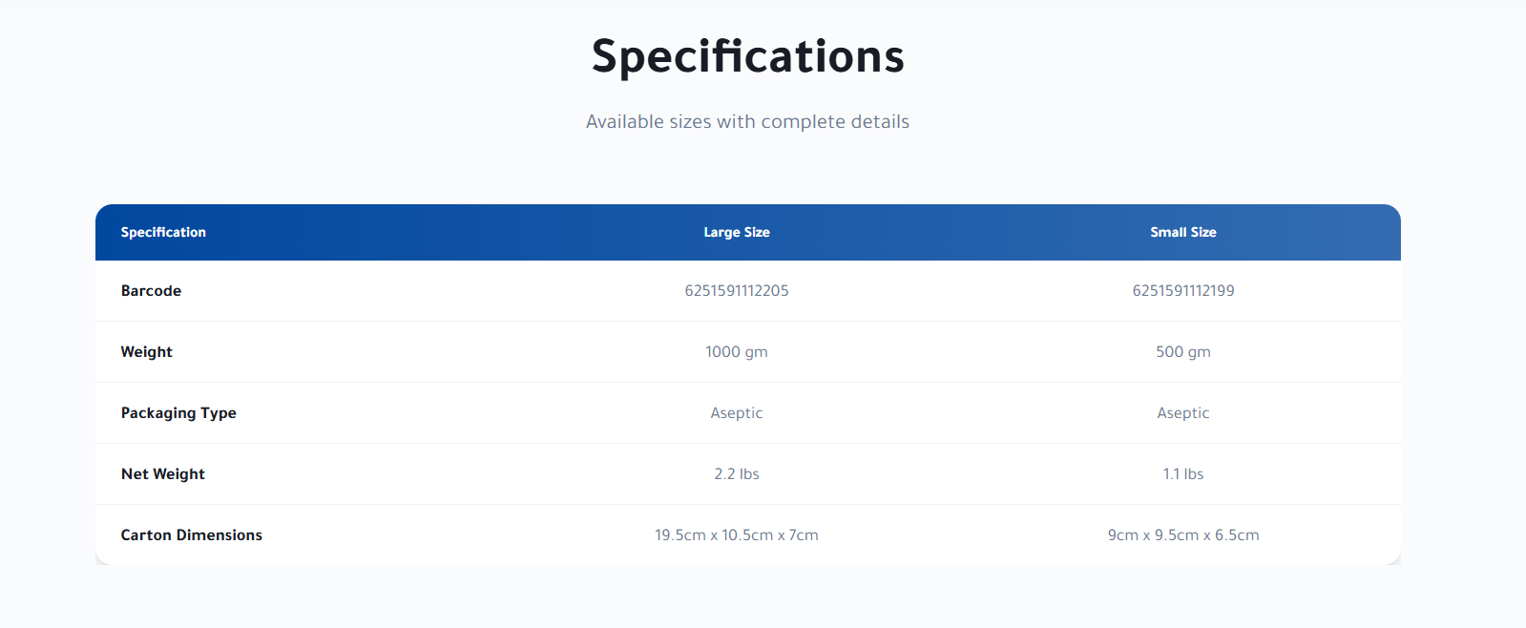
Change Aseptic to combi block
On all website

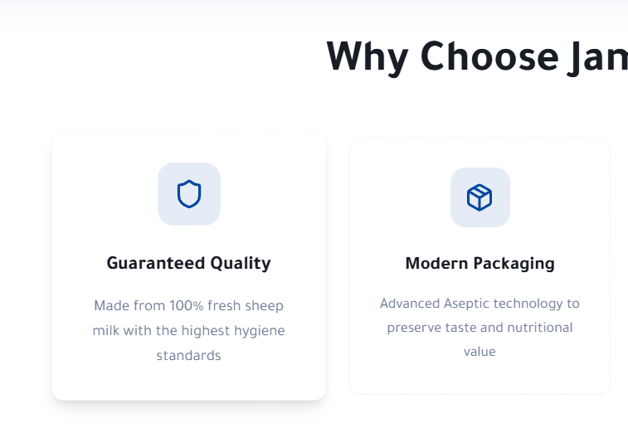
100% pure Jameed stones with the highest hygiene standards

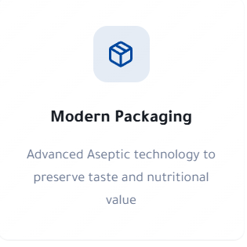change aseptic to combi blocks

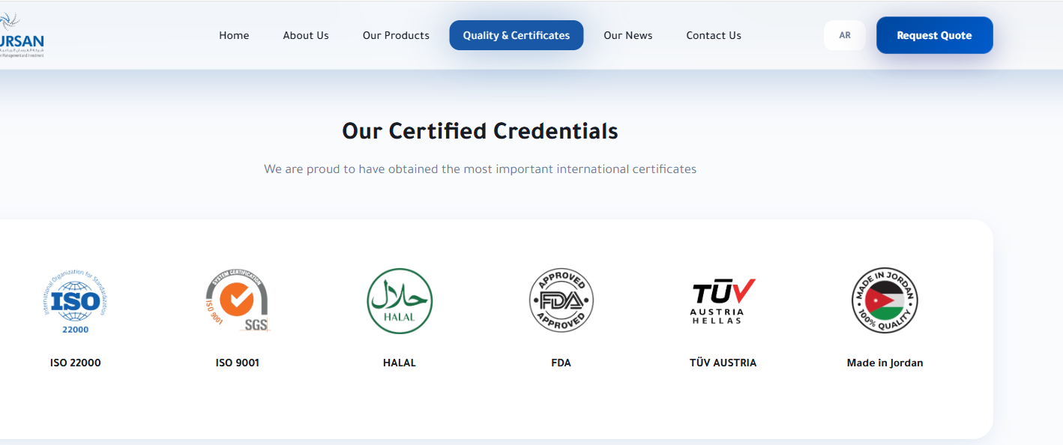

Change fda logo to

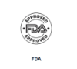

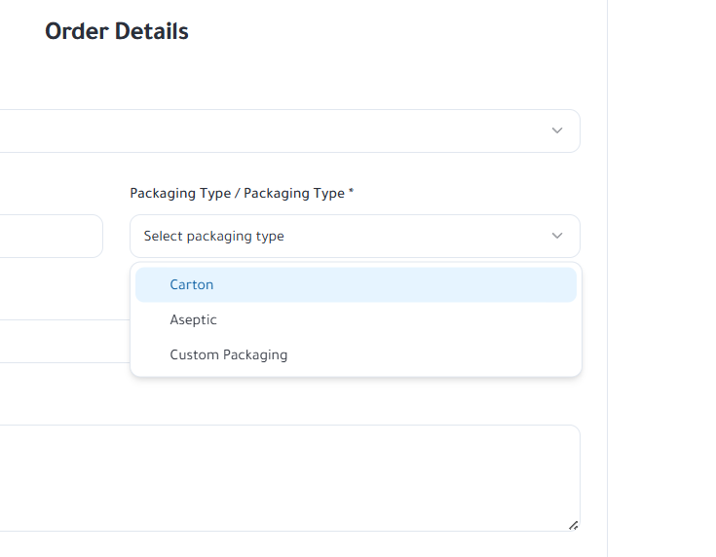
Keep carton only

